# The Backlog - الباكلوج

## Definition

**# Source**: **Chatgpt (GPT-5-Standard) at [8/27/2025]**

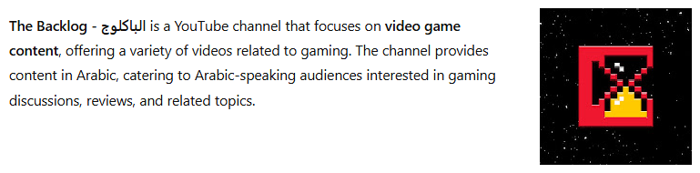

**The Backlog - الباكلوج** is a YouTube channel that focuses on **video game content**, offering a variety of videos related to gaming. The channel provides content in Arabic, catering to Arabic-speaking audiences interested in gaming discussions, reviews, and related topics.

## Key Highlights

**# Source**: **Chatgpt (GPT-5-Standard) at [8/27/2025]**

* **Content Focus**: The channel covers a range of gaming topics, including game reviews, discussions, and insights into the gaming industry.
* **Language**: All content is presented in Arabic, making it accessible to Arabic-speaking viewers.
* **Engagement**: The channel has garnered a dedicated following, with viewers engaging in discussions and sharing their thoughts on various gaming topics.
* **Content Style**: Videos are crafted to provide informative and entertaining content, appealing to both casual gamers and enthusiasts.

## Summary Table

**# Source**: **Chatgpt (GPT-5-Standard) at [8/27/2025]**

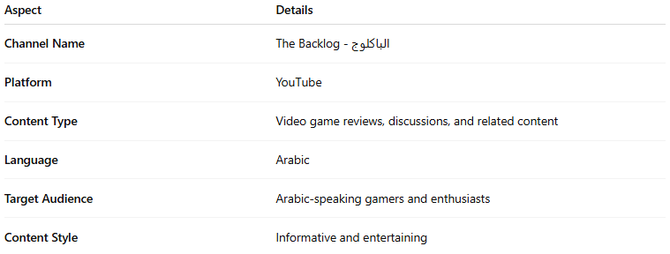

| **Aspect** | **Details** |
| --- | --- |
| **Channel Name** | The Backlog - الباكلوج |
| **Platform** | YouTube |
| **Content Type** | Video game reviews, discussions, and related content |
| **Language** | Arabic |
| **Target Audience** | Arabic-speaking gamers and enthusiasts |
| **Content Style** | Informative and entertaining |